im =imread('lenna512.bmp');
quantized_image =quantize(im,30);
figure;
imshow(quantized_image);
title('Quantized DCT image');
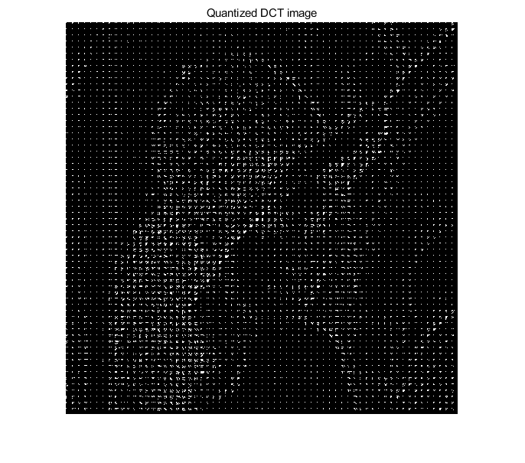
Published with MATLAB® R2019b

